**Emotion Detection and Reacting Emojis in chat**

BY

Abhishek N N 20BCE1025

M Hanuman Sai 19BPS1066

Vijay Gopu 19BPS1078

**A project report submitted to**

**Dr.Ganala Santoshi**

**SCHOOL OF COMPUTER SCIENCE & ENGINEERING**

**in partial fulfilment of the requirements for the course of**

**CSE 4015 – Human Computer Interaction**

IN

**B. Tech. COMPUTER SCIENCE ENGINEERING**



**Vandalur – Kelambakkam Road**

**Chennai – 600127**

**ABSTRACT**

Emojis are ways to indicate verbal cues. These cues have become an essential part of online chatting, product review, brand emotion, and numerous further. It also leads to adding data wisdom exploration devoted to emoji driven liar. With advancements in computer vision and deep learning, it's now possible to identify expressions from images. Interpersonal relations are affected by facial expressions, which convey verbal cues.

The automatic recognition of human facial expressions can be an important aspect of human and machine interactions and it may also be used in behavioural wisdom. The discovery of feelings in facial expressions has always been easy for humans but doing the same thing with a computer algorithm is relatively difficult. As a result of recent advancements in machine learning, it's now possible to recognise the emotions through the facial expressions of human.

In this deep learning design, we will classify human facial expressions to match and map with the corresponding emojis. Our design use human ’facial emotional expressions as system input to map emojis by identifying the expression. Despite that emojis can represent conduct, objects, nature, and other symbols, the most generally used emojis are faces which express emotion. An emoji is a visual representation of a vocal message. Online chats, product reviews, brand sentiment, and more all rely on these indications. Adding emoji-driven liar data exploration is also a result.

Machine learning & computational intelligence developments have made it possible to recognise facial expressions in photographs. Facial expressions influence interpersonal relationships because they carry language cues. In human-machine interactions, the ability to recognise human facial expressions automatically can be useful, and it can also be applied to behavioural wisdom. For humans, discovering emotions in facial gestures has always been simple, but doing so with a predictive algorithm is more challenging. Machine learning developments have made it possible to identify human emotions based on facial expressions. Emojis will be mapped to human facial emotions using this deep learning approach

**INTRODUCTION**

A person's facial expressions can identify their feelings because they correspond to their emotions. It can be considered as a concrete way of detecting whether persons are being honest or not based on facial expressions, since they are non-verbal ways of expressing emotion. We express our emotions through our voice, hand, and body gestures, and mostly through our facial expressions. People express their emotions in day-to-day interactions. Emojis are visual representations of emotions. Modern communication apps like Facebook, WhatsApp, Twitter, etc. use emoji to express emotions

The automatic recognition of human facial expressions can be an important aspect of natural human-machine interfaces; it may also be used in behavioural science. Humans can recognize facial expressions more quickly without any effort, but machine expression recognition is still difficult. Over the past few years, advances in face detection, mechanism for feature extraction, and techniques to classify facial expressions have been made, but it is difficult to develop an automated system to accomplish this task. Techniques for detecting facial expressions have been reported in two distinct ways. Using an explicit classifier, the first method allows separation of facial expressions, whereas the second method uses extracted facial highlights to determine facial recognition. In the facial action coding system (FACS), action units serve as markers for expression.

The goal of this analysis is to identify instances of emotional recognition in the data collected as part of routine operations. Happiness, fear, disgust, rage, sadness, surprise, and disdain are some of the most common emotions. The goal of this project is to build a deep learning model that can recognise and categorise face emotions. We can then use an emoji or an avatar to represent the labelled emotion.

**Existing system**

Current approaches focus mainly on facial investigation, maintaining the background intact and thus constructs a large number of unnecessary and misleading characteristics that confuse the process of CNN formation. Predicting the human emotions through their facial expression. Most of the current approaches are not so accurate. Some approaches take lot of time to detect the facial expressions.

**Problem Statement**

There is no problem as such in current technology solution but there is lack of feature. The lack of feature is not using human emotion for better user experience in social media such as automated reply of emojis in chat.

**Introduction to proposed model**

The project is to improvise the way of interaction between human and computer. The feature provided by the project is computer will predict emotion such as surprised, disgusted, fearful, sad, angry, happy of person by camera. Later this feature has endless use cases such as, it can be used for auto reply emojis in chat or social medias for automated liking and replay/skip of video or photo.

**Proposed Solution**

Proposed Solution : A Chat Application which can detect emotion and reply with emoji to interact hands free which runs on all popular browsers, on devices starting from low-medium end.

Previous interaction : by touch

Proposed interaction : by detecting emotion of user through camera (and touch)

**Components of the Model**

1. User Requirements: In this project we use user real time facial expression to map with the respective emoji. Where we have to detect the user facial emotion and have to map with the respective emoji with the detected emotion.

2. Hardware Requirement: Deep learning necessitates a massive amount of processing power. Graphic Processing Units (GPUs) with high performance are ideal because they can manage a big volume of operations in several cores with enough of memory. Managing numerous GPUs on-premises, on the other hand, can place a significant strain on internal resources and be extremely costly to grow.

3. Python 3.9 Python is a free open source tool for constructing and assessing deep learning models that is both powerful and simple to use. It covers the fast numerical computation libraries and lets you define and train neural network models with just a few lines of code.

4. Open CV OpenCV Python Server side Programming is a programming language that is 10 used to create web applications. OpenCV is a Python package for dealing with computer vision issues. Understanding and analyzing digital images by a computer, as well as processing and providing pertinent data once the image has been analyzed, are all examples of computer vision.

5. Pillow The most popular and de facto standard library in Python for loading and working with image data is Pillow. Pillow is an updated version of the Python Image Library, or PIL, and supports a range of simple and sophisticated image manipulation functionality. It is also the basis for simple image support in other Python libraries such as SciPy and Matplotlib.

6. Tensorflow(keras) Keras is compact, easy to learn, high-level Python library run on top of TensorFlow framework. It is made with focus of understanding deep learning techniques, such as creating layers for neural networks maintaining the concepts of shapes and mathematical details.

**Block Diagram**

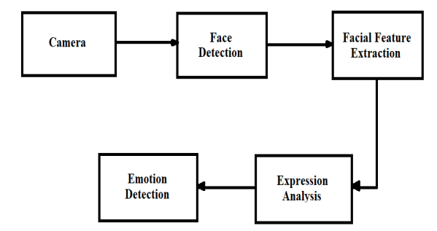

Figure 1: Block diagram of Facial Emotion Recognition

Facial emotion recognition steps are shown in Figure 1 which identifies the emotion of a person’s face displayed on the webcam. Firsty it model detects face based on pretrained data. After the presence of human is detected, then the camera will focus on captured face image alone. Using image processing concept an identification is done to know what kind of expression is the person showing along with accuracy of that particular emotion class. If the person does not show any expressions, then the emotion named neutral is displayed with the accuracy and emoji, which is one of the emotions for which the model is trained. This is the main part of project. Later we use this predicted emotion to auto reply in chat.

**Description of the components**

**Hardware**

Development Platform: Linux

Development Device: Any average hardware with Linux compatibility

User Device: Any Operating system with browser

**Softwares**

Development: Visual Studio Code, Google Colab, Chrome Dev Tools

User side: Any Browser

**Tech Stack**

HTML

CSS

JavaScript

Tenserflow

**Working Mechanism**

This system for recognizing the emotions from face was inspired by certain works around Convolutional Neural Network approach. These works encouraged us to come up with our own ideologies. The related work for the present model has been summarized below. Face Detection System Edwards et al. explains the recent approach in the form of 2 Dimensional or 3 Dimensional recognitions of face in progress, focusing mostly approach based on local, holistic (subspace), and hybrid quality. A comparative work between these approaches in terms of refining time, complexity, discrimination, and fitness will be carried out. They had concluded that local feature methods, which were the best option based on discrimination, rotation, relocation, convolution, and accuracy. They had a hope that this might further encourage researchers in this field to regulate and pay more attention to the usage of local procedures for face recognition systems. Face Recognition model Facial Emotion Recognition (FER) is the innovation that analyzes emotions from both static images and video to uncover data on one's passionate state. The complexity of emotions, the expected utilization of the innovation in any specific situation, and the contribution of new advances, for example, man-made reasoning raises critical protection risks. It has a place with the group of innovations which is referred to 'affective computing’, a multidisciplinary field of examination on computer’s abilities to perceive and decipher human feelings and emotional states and it frequently expands on Artificial Intelligence innovations.

**Procedure**

The proposed system carries out in three steps as Face Detection, Face Recognition and Face Classification. In the first step a video camera is used to capture real time human face and detect the exact location of face by a bounding box coordinates. Face detection is performed using Haar cascade detection with open CV library. The images detected have shapes, objects and landscapes etc. In this phase human face is detected and face features are extracted and stored in the database for face recognition. The CNN model is used to classify human emotions. Faces are recognized from the database and are compared to identify or detect the face through embedding vectors. First face is detected and then recognized with the database features and matching using CNN model training and testing database. Finally, the recognized human face is classified based on the expression in real time as Angry, fear, disgust, happy, neutral and surprise.

**Flow Diagram / Flow Chart**

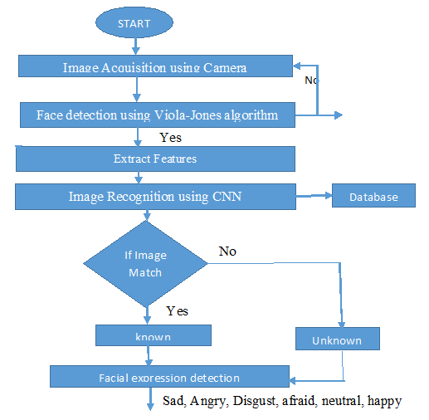

**Code**

https://github.com/7abhisheknn/reaction_by_detecting_face_emotions_camera

**Input:** video from camera

**Execution:** face emotion detection

**Output:** Automatic reply of emojis in chat

**Output Screenshots**

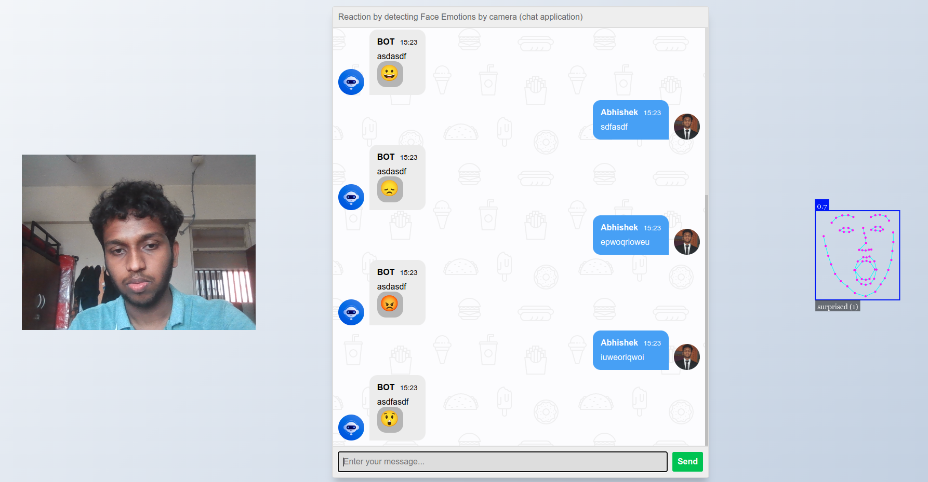

**Conclusion And Future Work**

Thus the project has come to end by providing solution as automatic emoji reply in chat for lack of feature in current technology as the problem statement by ml models neural nework which can predict emotion of user through realtime video.

The Future works of this projects are increasing the acurracy of emotion predictions and building and deploying a working business model for complete social media app.

**References**

[1] Pablos, S. M., García-Bermejo, J. G., Zalama Casanova, E., & López, J. (2015). Dynamic facial emotion recognition oriented to HCI applications. Interacting with Computers, 27(2), 99-119.

[2] M. Lyons, S. Akamatsu, M. Kamachi, and J. Gyoba, “Coding facial expressions with gabor wavelets,” in Automatic Face and Gesture Recognition, 1998. Proceedings. Third IEEE International Conference on, pp. 200–205, Apr 1998.

[3] Altarriba Bertran, F., Kim, S., Chang, M., Dagan, E., Duval, J., Isbister, K., & Turmo Turmo Vidal, L. (2021, May). Social Media as a Design and Research Site in HCI: Mapping Out Opportunities and Envisioning Future Uses. In Extended Abstracts of the 2021 CHI Conference on Human Factors in Computing Systems (pp. 1-5).

[4] Altarriba Bertran, F., Kim, S., Chang, M., Dagan, E., Duval, J., Isbister, K., & Turmo Turmo Vidal, L. (2021, May). Social Media as a Design and Research Site in HCI: Mapping Out Opportunities and Envisioning Future Uses. In Extended Abstracts of the 2021 CHI Conference on Human Factors in Computing Systems (pp. 1-5).

[5] https://justadudewhohacks.github.io/face-api.js/docs/index.html

[6] S Srivastava, P Gupta, P Kumar "Emotion Recognition Based Emoji Retrieval Using Deep Learning" 2021 - ieeexplore.ieee.org